

Install Guide
Version 2.1



Table of Contents
INTRODUCTION 1
1 Installing Metabuilder 3
1.1 Installation Procedure 3
1.2 Installing Windows Installer 5
1.3 Installing Microsoft .NET Framework 5
1.4 Installing Microsoft Data Access Components 6
1.5 Installing Microsoft Core XML Services 6
1.6 Installing Microsoft SQL Express 7
1.7 Installing Metabuilder 7
1.8 Registration 7
2 Restoring the Database 9
2.1 Restarting SQL Server Express (optional) 9
2.2 Restoring the Database 10
3 Metabuilder Support 17
3.1 Contact Us 17
3.2 Metabuilder Updates 17
3.3 Error Reporting Procedure 17
4 Troubleshooting 20
4.1 Windows VISTA User Account Control 20
4.2 Non-standard SQL Instance name 21
5 Metabuilder Server Installation 24
5.1 Minimum System Requirements 24

List of Figures
Figure 1: MetaBuilder Install Procedure – Part 1 4
Figure 2: MetaBuilder Install Procedure – Part 2 5
Figure 3: Registration Form 8
Figure 4: Successful Registration 8
Figure 5: Restart SQL Server Express 9
Figure 6: Connect to the Server 10
Figure 7: Expand Nodes in Object Explorer 10
Figure 8: Select Restore Database 11
Figure 9: Select Restore Destination and Source 12
Figure 10: Specify Backup - Add 13
Figure 11: Locate Backup File 13
Figure 12: Specify Backup - OK 14
Figure 13: Restore Selection 15
Figure 14: Restore Database – Options 16
Figure 15: Error Reporting Procedure - Part 1 18
Figure 16: Error Reporting Procedure - Part 2 19
Figure 17: User Account Control - Link 20
Figure 18: User Account Control Switched Off 21
Figure 19: Connect to Server 21
Figure 20: Successful Connection 22
List of Tables
Table 1: Add-on Product Components 1
Table 2: Metabuilder Minimum System Requirement 2
Table 3: Contact Information 17
Table 4: SQL Server 2005 Standard Edition Minimum System Requirement 24


Introduction

Metabuilder is a Business Modelling Tool developed around the internationally acclaimed DISCON Business Engineering Methodology, which has the proven ability to ensure “Control over Change”, in any business environment. Control over strategy, functions, processes and assets are critical to the future of any organisation. The ability of an organisation to rapidly recognize and react to a changing environment implies a well established “Control over Architecture” within that organisation. Metabuilder ensures that an organisation has a sufficient Business Modelling Tool giving them the ability to apply a Continuous Business Engineering approach within the organisation.
Metabuilder consists of a rules engine to ensure the delivery of the Meta model and a graphical interface to enable modelling of business strategy, business structures, process flows, infrastructure requirements, etc. These elements are supported by an intelligent database for the control and storage of model diagrams and their associated business intelligence.
This manual serves to document the instructions that will guide you through the successful installation of Metabuilder on your computer. In this guide you will find instructions for:
- Installing a new version of Metabuilder when you have a computer with no previous Metabuilder software installation.
- Upgrading Metabuilder when you already have a version of Metabuilder on your computer.
During the installation process, you will need:
- Your Metabuilder installation disc (or in some cases only the Metabuilder Setup file).
- Your Metabuilder license key. You can find your license key by contacting the Metabuilder Support Centre (Refer to Part 3: Metabuilder Support).
In order for you to complete the successful installation of Metabuilder (Metabuilder Setup-x.x.xxxx.xxxxx.exe) the following Add-on components (prerequisites) also need to be installed:
Table 1: Add-on Product Components
Windows Installer 3.1 Redistributable (V2) (Windows XP); or Windows Installer 4.0 (Windows Vista) (Included)
Microsoft .NET Framework version 2.0 (x86) Redistributable Package
Microsoft Data Access Components (MDAC) 2.7 or later
Microsoft Core XML Services (MSXML) 6.0
SQL Server 2005 Express Edition with Advanced Services SP2 (for Metabuilder Client)

Note: For 32-bit platforms, install the 32-bit version of Microsoft .NET Framework 2.0. No 64-bit platform is currently supported. All of the Add-on components are Freeware and are available on the Installation Disc. We recommend using the vendor sites to verify any software upgrades prior to installing any element of Metabuilder.

Note: Metabuilder software is only installed on the Client Machine and not on the Server Machine for a Client-Server topology. (Only SQL Server Standard Edition software is required on the Server Machine).
The Metabuilder software has the following minimum system requirements (Client Machine):
Table 2: Metabuilder Minimum System Requirement
Component | Requirement
Operating System | - Windows 2000 Professional Edition with SP 4 or later  - Windows XP with SP 2 or later (32-bit)  - Windows Vista (32-bit)  - Windows Server 2003 Enterprise Edition, Standard Edition, or Datacenter Edition with SP 1 or later
Browser | Internet Explorer 6.0 or later
Memory | Minimum of 512 MB of RAM (1 GB or more is recommended)
Hard Disk Space | 20 MB of available hard disk space (Metabuilder Software)
Display | 1024 x 768 or higher-resolution display with 256 colours
Drive | A CD or DVD drive, as appropriate, is required for installation from disc
Pointing Device | Microsoft mouse or compatible pointing device
Other | An Internet connection is required for registration of the Metabuilder software

Note: Actual requirements will vary based on your system configuration and the applications and features you choose to install. Additional available hard-disk space may be required.

Part One

Installing Metabuilder

Installation Procedure
After following the manual installation instructions, please be sure to register your copy of Metabuilder. Before getting started, first carefully read the instructions contained in this installation guide.
Before installing Metabuilder, you must first determine whether you are running a 32-bit or 64-bit version of the Windows Operating System.
Note: Metabuilder currently only supports 32-bit Operating Systems.
To determine the type of operating system that you are running in Windows XP, follow these steps:
Step 1. Click Start, click Run, type sysdm.cpl, and then click OK.

Step 2. Click the General tab. The operating system appears as follows:
- For a 64-bit operating system version: Microsoft Windows XP Professional x64 Edition Version <Year> appears under System.
- For a 32-bit operating system version: Microsoft Windows XP Professional Version <Year> appears under System.
To determine the type of operating system that you are running in Windows Vista, follow these steps:

Step 1. Click Start, click Settings, click Control Panel, and then click System.

Step 2. The operating system appears as follows:
- For a 64-bit version operating system: 64-bit Operating System appears for the System type under System.
- For a 32-bit version operating system: 32-bit Operating System appears for the System type under System.

The sequence in which Metabuilder with the add-on components should be installed is depicted below:
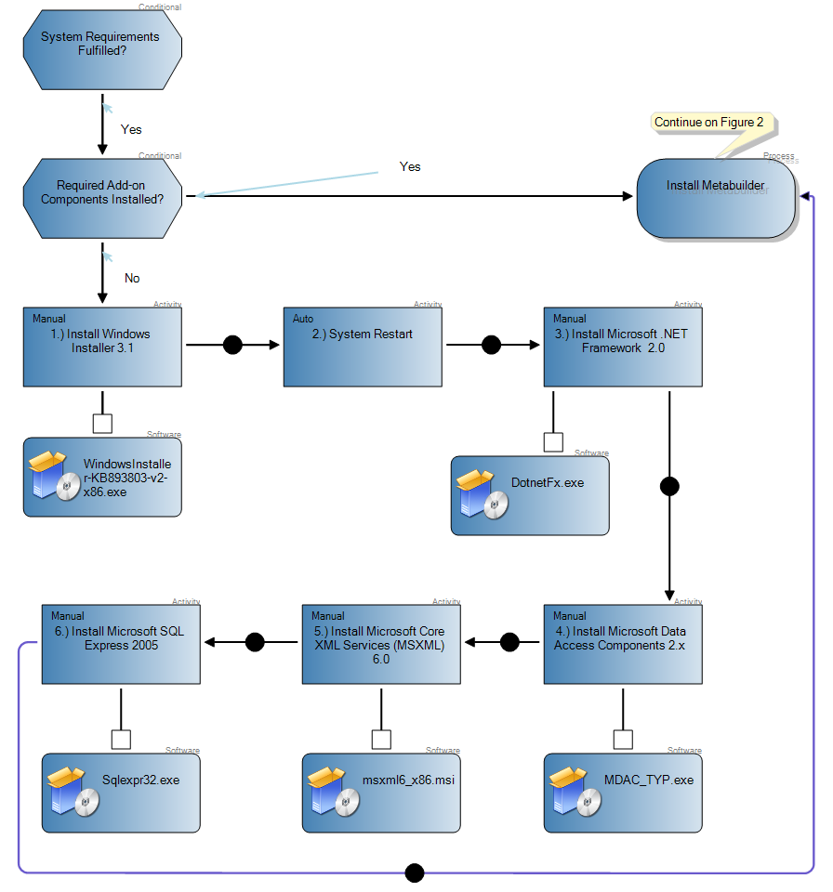
Figure 1: MetaBuilder Install Procedure – Part 1
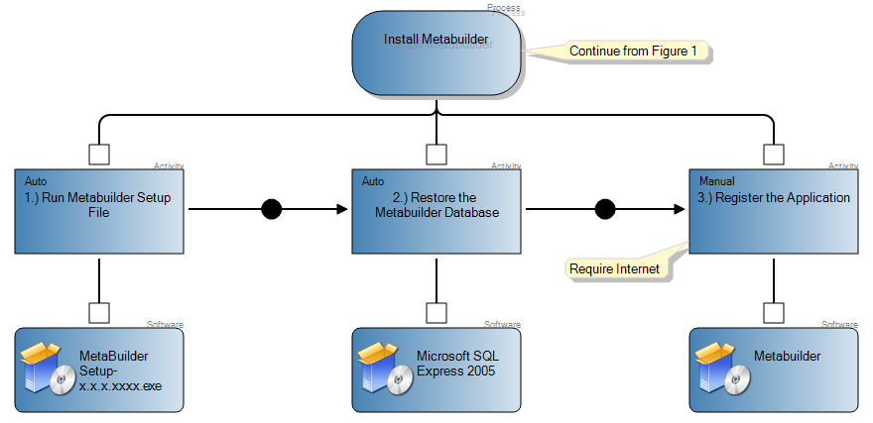
Figure 2: MetaBuilder Install Procedure – Part 2

Installing Windows Installer
Microsoft Windows Installer is a component of your Windows operating system that provides a standard foundation for installing and uninstalling software. Microsoft .NET Framework requires Windows Installer for installation, maintenance, and uninstallation.
Windows Installer 3.1 Redistributable (V2) is supplied with the installation disc. To install Windows Installer, open the folder “Required\Prerequisites\Microsoft Windows Installer 3.1 Redistributable” on the installation disc and run the WindowsInstaller-KB 893803-v2-x86.exe file. Follow all of the onscreen prompts.
Alternatively Windows Installer 3.1 Redistributable (V2) can be downloaded from the Microsoft website. For more information on Windows Installer 3.1, please visit the Microsoft website by first accessing the Metabuilder website at http://www.metabuilder.co.za/downloads/releaselog.htm. Scroll to the Prerequisites section and click on the Windows Installer 3.1 link.
Note: Windows Installer 4.0 is included with Windows Vista.
To download the WindowsInstaller-KB893803-v2-x86.exe file, click the Download button on the appropriate page to start the download. To start the installation immediately, click Run. Follow all of the onscreen prompts and when the installation is complete, a confirmation screen is displayed. Click OK to close the confirmation window.

Installing Microsoft .NET Framework
Important: Ensure that you have the latest service pack and critical updates for the version of Windows that you are running. To find recent security updates, visit Windows Update.

Important: If you have installed previous pre-release versions of .NET Framework v2.0, such as Beta 1, Beta 2 or Community Technical Preview (CTP) builds, then you must uninstall these versions via Add/Remove Programs in Control Panel before installing this final release version.
Microsoft .NET Framework is a software component that is a part of several Microsoft Windows operating systems. It has a large library of pre-coded solutions to common programming problems and manages the execution of programs written specifically for the framework. The .NET Framework is a key Microsoft offering and is intended to be used by most new applications created for the Windows platform.
Microsoft .NET Framework V 2.0 (x86) Redistributable Package is supplied with the installation disc. To install Microsoft .NET Framework, open the folder “Required\Prerequisites\ Microsoft .NET Framework 2” on the installation disc and run the dotnetfx.exe file. Follow all of the onscreen prompts.
Alternatively Microsoft .NET Framework V2.0 can be downloaded form the Microsoft website. For more information on Microsoft .NET Framework, please visit the Microsoft website by first accessing the Metabuilder website at http://www.metabuilder.co.za/downloads/releaselog.htm. Scroll to the Prerequisites section and click on the Microsoft .NET Framework 2 SP1 link.
To download the dotnetfx.exe file, click the Download button on the appropriate page to start the download. To start the installation immediately, click Run. Follow all of the onscreen prompts and when the installation is complete, a confirmation screen is displayed. Click OK to close the confirmation window.

Installing Microsoft Data Access Components
Microsoft Data Access Components (MDAC) contains core Data Access components such as the Microsoft SQL Server™ OLE DB provider and ODBC driver.
MDAC is supplied with the installation disc. To install MDAC, open the folder “Required\ Prerequisites\Microsoft Data Access Components (MDAC) 2.x” on the installation disc and run the MDAC_TYP.exe file. Follow all of the onscreen prompts.
Alternatively MDAC can be downloaded from the Microsoft website. For more information on MDAC, please visit the Microsoft website by first accessing the Metabuilder website at http://www.metabuilder.co.za/downloads/releaselog.htm. Scroll to the Prerequisites section and click on the MDAC 2.8 link.
To download the MDAC_TYP.exe file, click the Download button on the appropriate page to start the download. To start the installation immediately, click Run. Follow all of the onscreen prompts and when the installation is complete, a confirmation screen is displayed. Click OK to close the confirmation window.

Installing Microsoft Core XML Services
Microsoft Core XML Services (MSXML) is an application for processing Extensible Stylesheet Language Transformation in an XML file. MSXML is used to create, parse, and process XML documents.
Microsoft Core XML Services (MSXML) 6.0 is supplied with the installation disc. To install MSXML, open the folder “Required\Prerequisites\Microsoft Core XML Services (MSXML) 6.0” on the installation disc and run the msxml6_x86.msi file. Follow all of the onscreen prompts.
Alternatively Microsoft Core XML Services (MSXML) 6.0 can be downloaded from the Microsoft website. For more information on Microsoft Core XML Services, please visit the Microsoft website by first accessing the Metabuilder website at http://www.metabuilder.co.za/downloads/ releaselog.htm. Scroll to the Prerequisites section and click on the Microsoft XML 6 (X86) link.
To download the msxml6_x86.msi file, click the Download button on the appropriate page to start the download. To start the installation immediately, click Run. Follow all of the onscreen prompts and when the installation is complete, a confirmation screen is displayed. Click OK to close the confirmation window.

Installing Microsoft SQL Express
Microsoft SQL Server 2005 Express Edition (SQL Server Express) is a free and easy-to-use version of SQL Server 2005 that replaces the Microsoft Desktop Engine (MSDE). SQL Server Express can be redistributed (subject to agreement), and can function as the client database as well as a basic server database.
Microsoft SQL Server 2005 Express Edition is supplied with the installation disc. To install Microsoft SQL Server 2005 Express Edition, open the folder “Required\Prerequisites\SQL Server 2005 Express Edition with Advanced Services SP2” on the installation disc and run the SQLEXPR_ADV.exe file. Follow all of the onscreen prompts.
Alternatively Microsoft SQL Server 2005 Express Edition can be downloaded from the Microsoft website. For more information on Microsoft SQL Server 2005 Express Edition, please visit the Microsoft website by first accessing the Metabuilder website at http://www.metabuilder.co.za/ downloads/releaselog.htm. Scroll to the Prerequisites section and click on the Microsoft SQL Server Express 2005 with Advanced Features: More Info link.
To download the SQLEXPR_ADV.exe file, click the Microsoft SQL Server Express 2005 with Advanced Features link to start the download. To start the installation immediately, click Run. Follow all of the onscreen prompts and when the installation is complete, a confirmation screen is displayed. Click OK to close the confirmation window.

Installing Metabuilder
The Metabuilder Setup file is supplied with the installation disc. To install Metabuilder, open the folder “Required” on the installation disc and run the MetaBuilder Setup-x.x.xxxx.xxxx.exe file. Follow all of the onscreen prompts.

Registration
Each installation of MetaBuilder allows a 14 day trial period. Once that 14 day trial period has expired, you will be required to register your copy of Metabuilder for use. To register and activate your copy of Metabuilder, follow the steps below:

The Registration Form automatically appears as part of the Metabuilder installation or when the trail period has expired.

If not registering with the install you can register later by accessing the Registration Form. Click Help, click About and then click Register to access the Registration Form. Once the Registration Form is completed, click on the Register Application button to submit the registration application.

The following information is compulsory:
- First Name.
- Last Name.
- Email.
- License Key.
Note: An Internet Connection is required to complete the registration in this manner. Your license key can be obtained from support@discon.co.za.
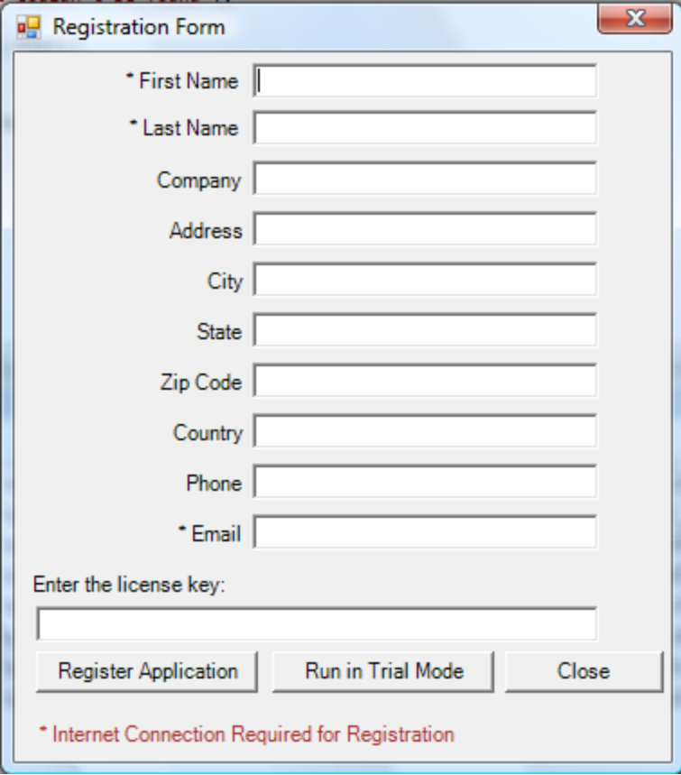
Figure 3: Registration Form

Once the registration is successful you will be presented with the Registration Successful dialog.
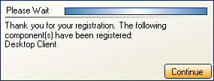
Figure 4: Successful Registration

Note: If you encounter any issues installing Metabuilder or any of the other required components, please contact the MetaBuilder Support Centre and report your issue for more assistance.

Part Two

Restoring the Database
The sequence in which the Metabuilder database can be manually restored is depicted below.

Restarting SQL Server Express (optional)
Note: If a message “Database in Use” is displayed, it might be necessary to restart the SQL Server Express before restoring the database.
In order to restart SQL Server Express, proceed as follows:

Step 1. Click Start, click Programs, click Microsoft SQL Server 2005, and click SQL Server Management Studio Express CTP.
Step 2. Click Connect to connect to the server.

Step 3. Right-click the top left node in the Object Explorer and select Restart.
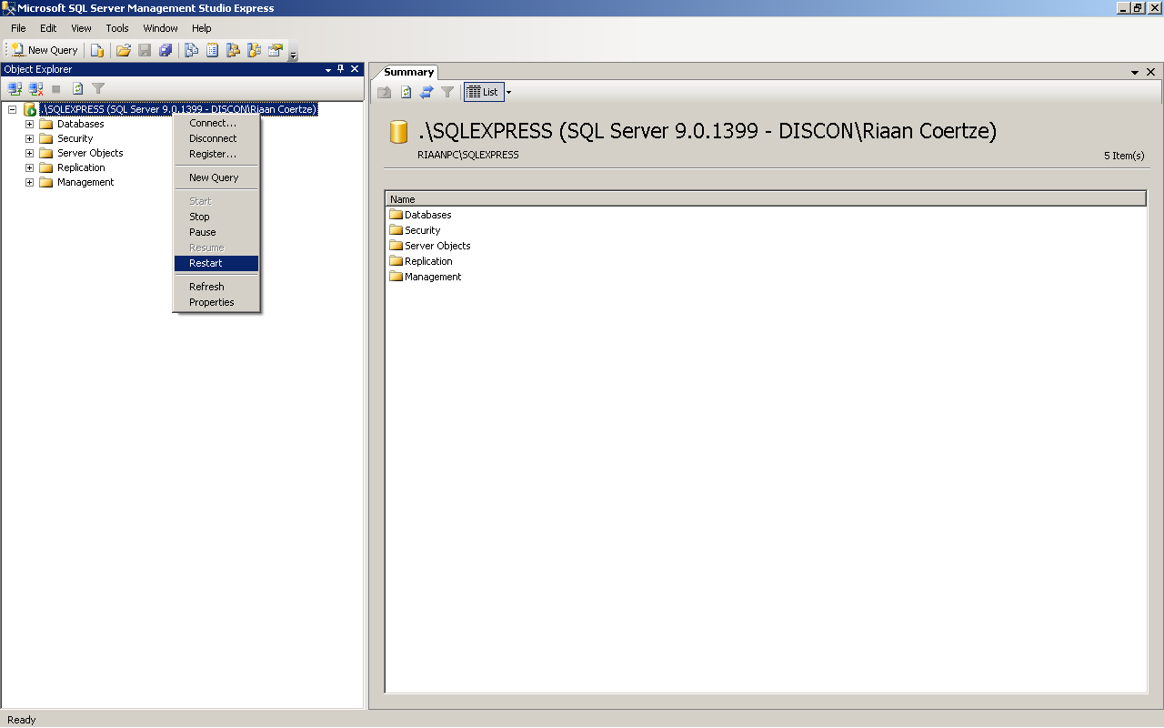
Figure 5: Restart SQL Server Express

Restoring the Database
In order to restore the Metabuilder database, proceed as follows:

Step 1. Click Start, click Programs, click Microsoft SQL Server 2005, and click SQL Server Management Studio Express CTP.
Step 2. Click Connect to connect to the server.
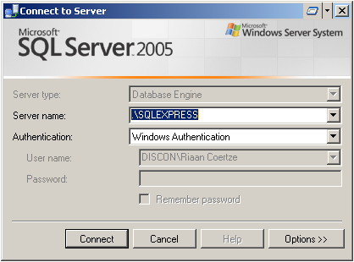
Step 2
Figure 6: Connect to the Server
Step 3. If it is not expanded, expand the top left node in the Object Explorer.
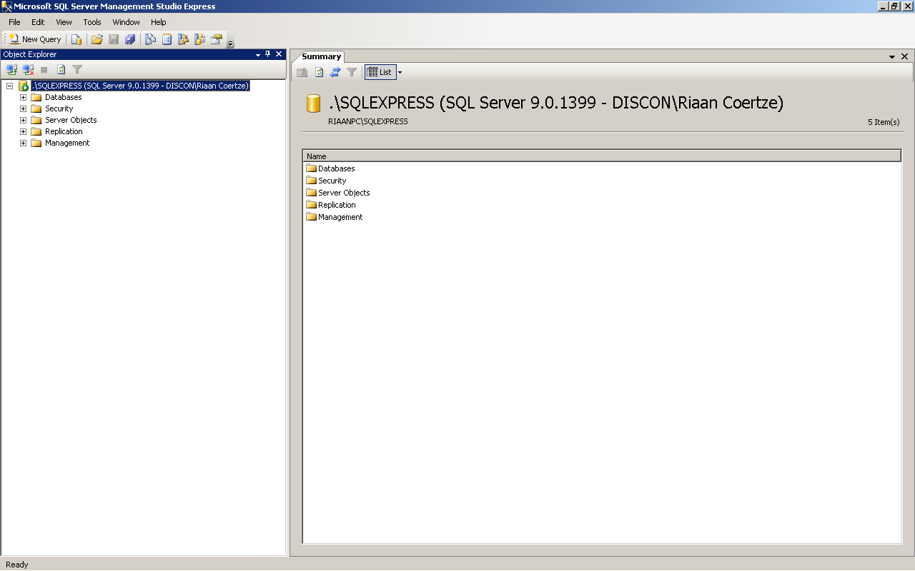
Step 3
Figure 7: Expand Nodes in Object Explorer

Step 4. Right-click on Databases and select Restore Database.
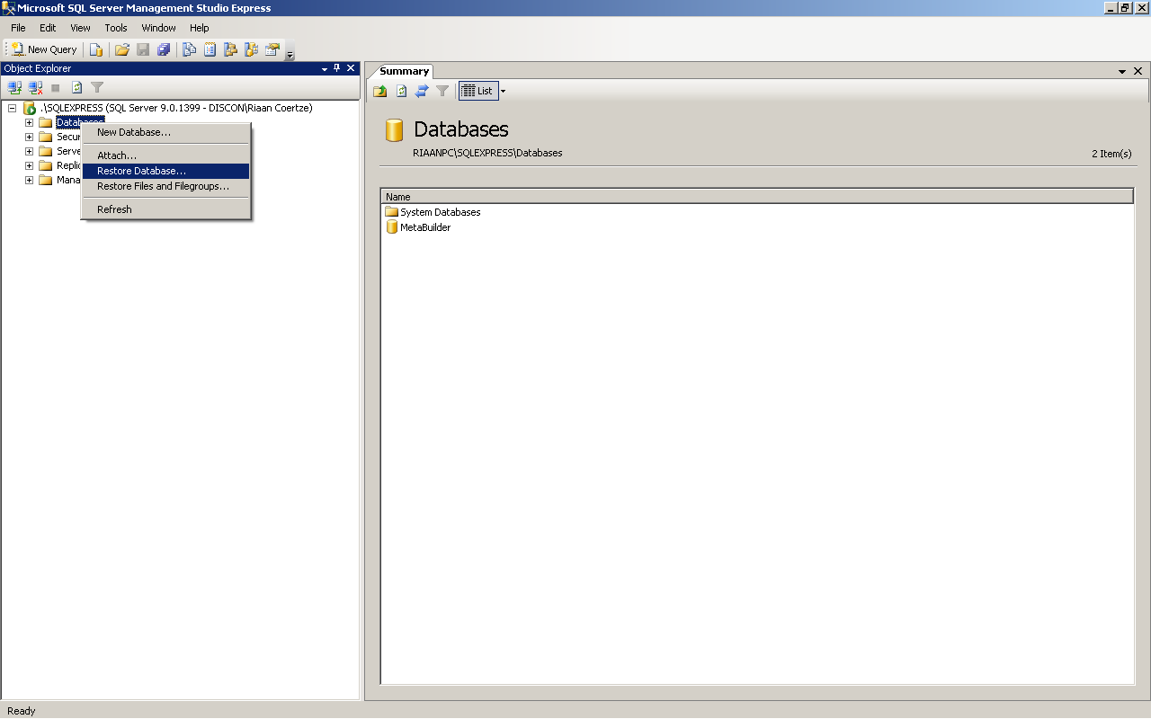
Step 4
Figure 8: Select Restore Database

Step 5. Type MetaBuilder in the To Database edit field.

Step 6. Check the From Device radio button.

Step 7. Click on the “…” button.
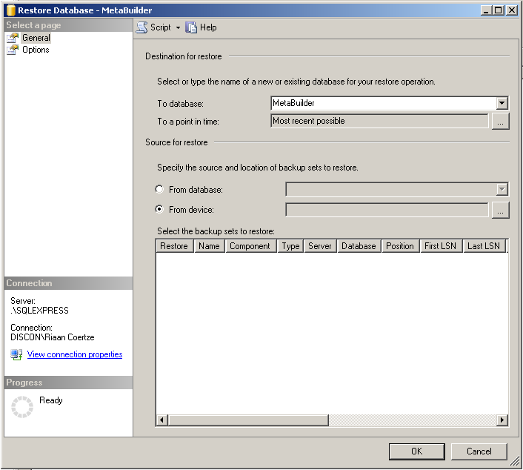
Step 5
Step 6
Step 7
Figure 9: Select Restore Destination and Source

Step 8. Click on “Add”
Step 9. Locate the backup file MetaBuilderDatabase.bak on the installation disc and click OK.

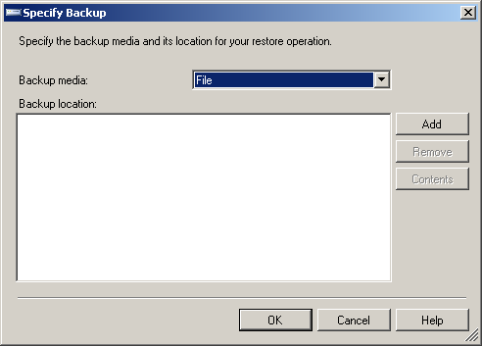
Step 8
Figure 10: Specify Backup - Add

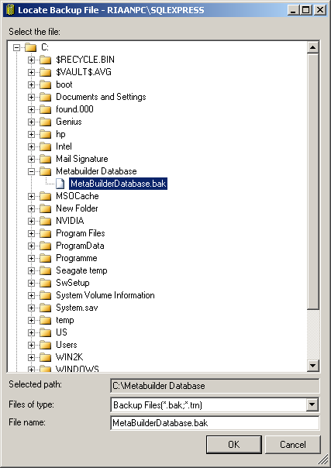
Step 9
Figure 11: Locate Backup File

Step 10. Click OK.
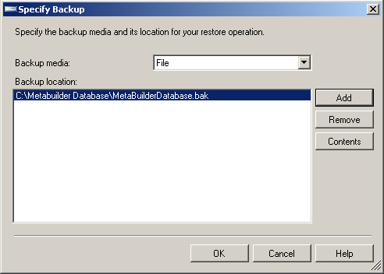
Step 10
Figure 12: Specify Backup - OK

Step 11. Check the Restore option.

Step 12. Click on Options.
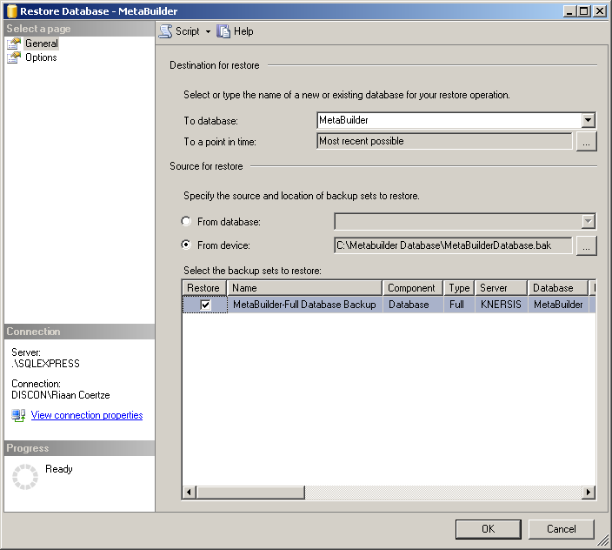
Step 11
Step 12
Figure 13: Restore Selection

Step 13. Change the Restore As paths to the following:
Step 13a. C:\Program Files\Microsoft SQL Server\MSSQL.1\MSSQL\Data\MetaBuilder.mdf
Step 13b. C:\Program Files\Microsoft SQL Server\MSSQL.1\MSSQL\Data\MetaBuilder.ldf
(or any other valid location on your machine)

Step 14. Click OK.
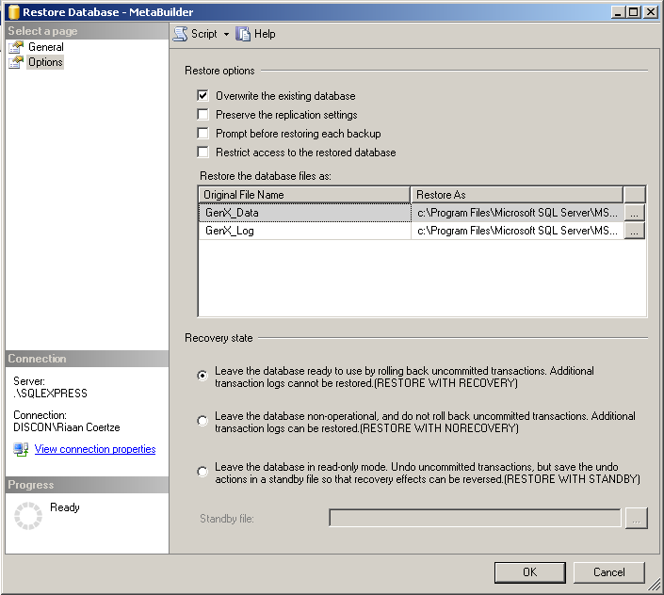
Step 13a
Step 14
Step 13b
Figure 14: Restore Database – Options

Note: The database should restore normally. If you encounter any errors, try copying the MetaBuilderDatabase.bak file to another location (e.g. “c:\temp”) before restoring.

Part Three

Metabuilder Support

Contact Us
For technical support, please contact us at:
Table 3: Contact Information
Phone | +27 (0)12 667 5975
E-mail | support@discon.co.za
Website | http://www.discon.co.za

Metabuilder Updates
"Update" means a subsequent release of Metabuilder which Discon generally makes available for to its supported clients at no additional license fee, other than shipping charges if applicable. Updates do not include any release, option or future program that Discon licenses separately. Updates are provided when available, and Discon is under no obligation to develop any future programs or functionality. Any updates made available will be delivered to you, or made available to you for download. You shall be responsible for copying, downloading and installing the updates.
Some of these updates may include Metabuilder updates, fixes, critical patch updates, upgrade scripts or major product and technology releases.

Error Reporting Procedure
Assisting our clients is a primary concern, and Discon recognises that problems need to be resolved as quickly and efficiently as possible.
Your technical contacts are the sole liaisons between you and Discon for technical support of Metabuilder. It is the recommended standard that your technical contacts are trained representatives of your company. Such training shall include initial basic product training and, as needed, supplemental training appropriate for specific role or implementation phase. Your technical contacts should be knowledgeable about Metabuilder and your environment in order to help resolve issues and to assist Discon in analysing and resolving support requests.
Assistance with support requests will be between Monday through Friday during local business hours, excluding holidays; local business hours are 8:00 A.M. to 5:00 P.M. (Standard time zone: UTC/GMT +2 hours).
In order for us to provide you with the best possible technical support, we recommend that you follow the error reporting procedure as depicted in Figure 15 and 16.
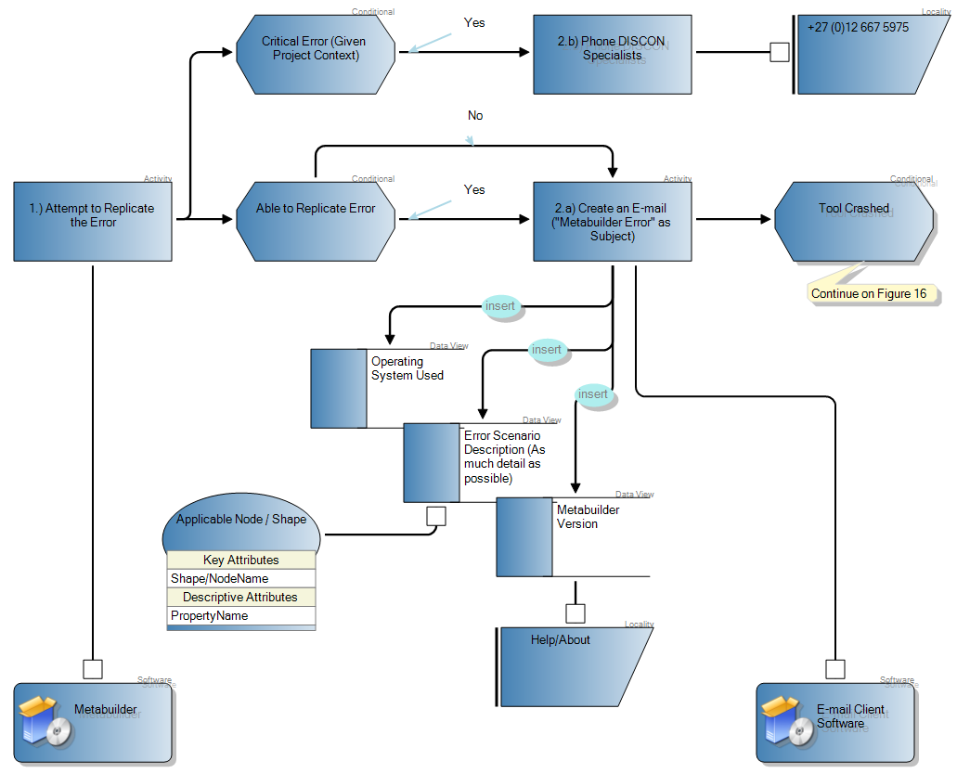
Figure 15: Error Reporting Procedure - Part 1

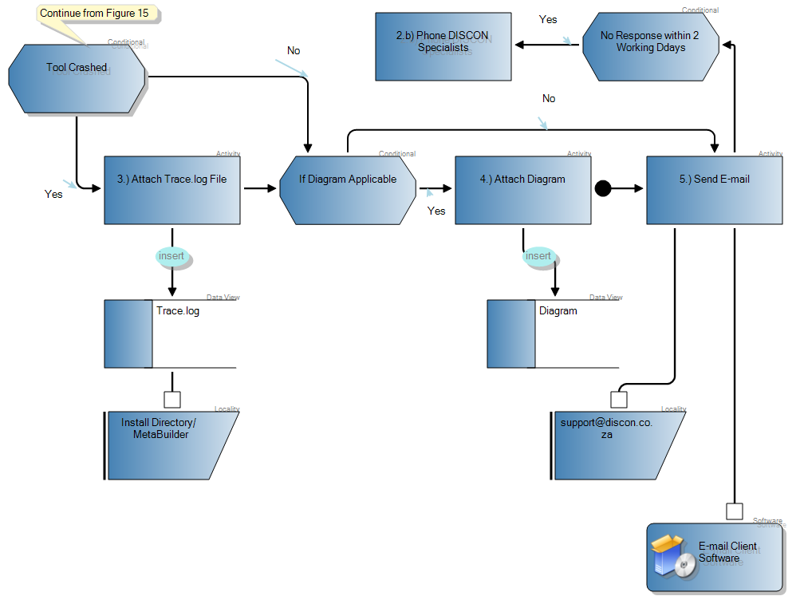
Figure 16: Error Reporting Procedure - Part 2

Part Four

Troubleshooting

Windows VISTA User Account Control
If you encounter any User Account problems on a Windows Vista operating system during installation, ensure that the User Account Control is turned off before installing.

Step 1. Click Start, click Settings, click Control Panel and type in UAC into the search box.
Step 2. Click on the link Turn User Account Control (UAC) on or off.

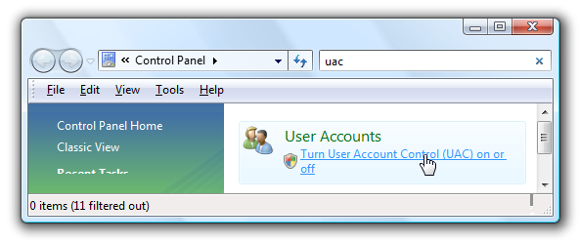
Figure 17: User Account Control - Link
Step 3. On the next screen you should uncheck the box for Use User Account Control (UAC), and then click on the OK button.
Step 4. You'll need to reboot your computer before the changes take effect.
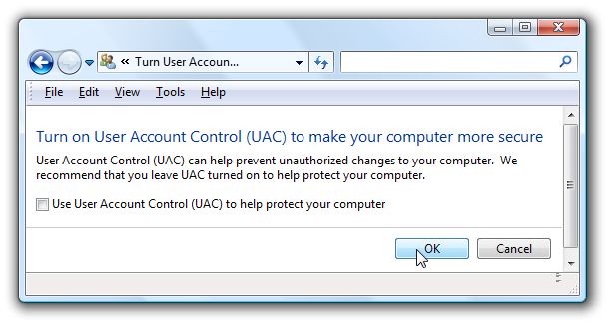
Figure 18: User Account Control Switched Off

Non-standard SQL Instance name
If you cannot connect to SQL Server Express it could be that the Server Name is not standard. This could be as a result of a non-default selection made during the installation of SQL Server Express. To resolve this problem, proceed as follows:

Step 1. You need to find the correct connection string using SQL Server Management Studio. Click Start, click Programs, click Microsoft SQL Server 2005, and click SQL Server Management Studio Express CTP.
Step 2. Copy the highlighted text displayed in the Server Name edit field.
Step 3. Click Connect to connect to the server.
Figure 19: Connect to Server
Note: If at this point you see a similar screen as depicted in Figure 20, the connection was successful and the problem is solved. Alternatively, continue with the next steps.
Figure 20: Successful Connection
Step 4. If you were unable to connect, attempt to change the Server Name to just a full stop “.” and attempt to connect again. If you were able to connect the problem is solved and the Server Name will be “.”
Step 5. Ensure that the Metabuilder database is available by expanding the Databases tree node in the Object Explorer.
Note: If the database is not available, refer Part 2 of this guide to restore the database.
Step 6. Open the file: C:\Program Files\DISCON Specialists\MetaBuilder\MetaBuilder. exe.config using Notepad.

Step 7. Search for netTiersConnectionString.

Step 8. Change the value for the Server e.g.: <add name="netTiersConnectionString" connectionString="Server=XXX; Initial Catalog=Metabuilder; Integrated Security=true ;"/> by replacing the XXX part with the Server Name entered in Step 4.

Step 9. Save the file.

Step 10. Open the file: C:\Program Files\DISCON Specialists\MetaBuilder\settings.xml using Notepad.

Step 11. Locate the following entry: <Database_LocalInstanceConnectionString> Server=XXX; Initial Catalog=Metabuilder; Integrated Security=true; </Database_LocalInstance ConnectionString> and replace the XXX part with the Server Name entered in Step 4.

Step 12. Save the file.

Step 13. Attempt to start Metabuilder.

Part Five

Metabuilder Server Installation

Minimum System Requirements
Note: Metabuilder software is only installed on the Client Machine and not on the Server Machine for a Client-Server topology. (Only SQL Server Standard Edition software is required on the Server Machine).
The SQL Server 2005 Standard Edition software has the following minimum system requirements (Server Machine):
Table 4: SQL Server 2005 Standard Edition Minimum System Requirement
Component | Requirement
Operating System | - Microsoft Windows 2000 Server with Service Pack (SP) 4 or later  - Windows 2000 Professional Edition with SP 4 or later  - Windows XP with SP 2 or later  - Windows Server 2003 Enterprise Edition, Standard Edition, or Datacenter Edition with SP 1 or later  - Windows Small Business Server 2003 with SP 1 or later
Browser | Internet Explorer 6.0 or later
Memory | Minimum of 512 MB of RAM (1 GB or more is recommended)
Hard Disk Space | - Approximately 350 MB of available hard-disk space for the recommended installation  - Approximately 425 MB of additional available hard-disk space for SQL Server Books Online, SQL Server Mobile Books Online, and sample databases  - Approximately 50 GB of additional available hard-disk space for the Metabuilder database
Display | 1024 x 768 or higher-resolution display with 256 colours
Component | Requirement
Drive | A CD or DVD drive, as appropriate, is required for installation from disc
Pointing Device | Microsoft mouse or compatible pointing device
Other | For Reporting Services, you need Microsoft Internet Information Services (IIS) 5.0 or later, and ASP.NET 2.0 or later.  Appropriate means for the back-up of the SQL Server database.

Note: Actual requirements will vary based on your system configuration and the applications and features you choose to install. Additional available hard-disk space may be required.

Note: For the Metabuilder Client-Server Topology, the database needs also to be restored on the Server Machine. All instances of Metabuilder for the Client-Server Topology need to connect to the Server Database.

